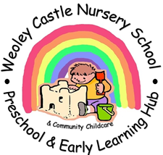

Dear Parents. Carers and friends of Weoley Castle Nursery School, Preschool & Early Learning Hub,

As this school year comes to an end I would like to thank you all for the wonderful support and encouragement that you have given to me and my staff team. We have shared a fantastic year and our children have learned so much.

Your feedback has clearly demonstrated how pleased you all are with the quality of learning and care provided here for your children and yourselves. We have a great partnership with you all and we really value your kindness, friendship and consideration as we try to do our very best to enable our children to learn and develop the skills and knowledge they need as they move on to the next step in their education.

We hope that you have a wonderful Summer and wish you all every success as you move on. Always here if you need us for a hug, a chat or a coffee!

When our OfSted report from HMI Keri Baylis is published we will let you have a copy. This report is yours as well as ours because it is only as a partnership, working together, that we can achieve such positive outcomes for our children.

Thank you

Love

Lesley and the team at Weoley xxxxx